**Automate an E-Commerce Web Application**

This document contains sections for:

* Sprint planning and Task completion
* Core concepts used in project
* Demonstrating the product capabilities, appearance, and user interactions.
* Conclusions

The code for this project is hosted <https://github.com/Prateekdu/Phase-1-Practice-Project.git>

Phase 5🡪Automate an E-Commerce Web Application

The project is developed by Prateek Dubey.

Sprints planning and Task completion

The project is planned to be completed in 1 sprint. Tasks assumed to be completed in the sprint are:

* Creating the flow of the application
* Initializing git repository to track changes as development progresses.
* Writing the Angular program to fulfill the requirements of the project.
* Testing the Angular program with different kinds of User input
* Pushing code to GitHub.
* Creating this specification document highlighting application capabilities, appearance, and user interactions.

Core concepts used in project

* Selenium Library
* Eclipse IDE
* TestNG Library
* Maven

Demonstrating the product capabilities, appearance, and user interactions

demonstrate the product capabilities, below are the sub-sections configured to highlight appearance and user interactions for the project:

**ChromeAutomation.java**

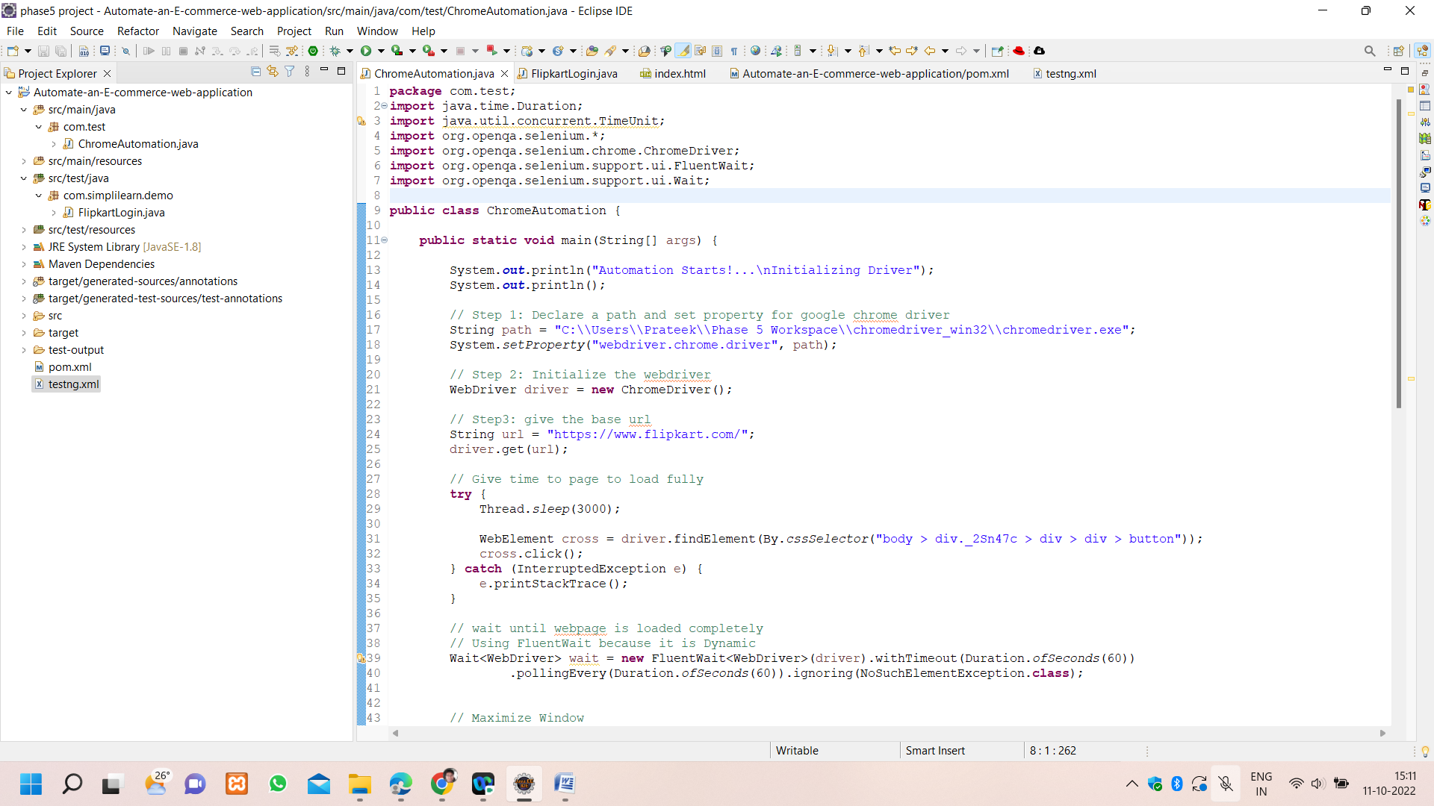

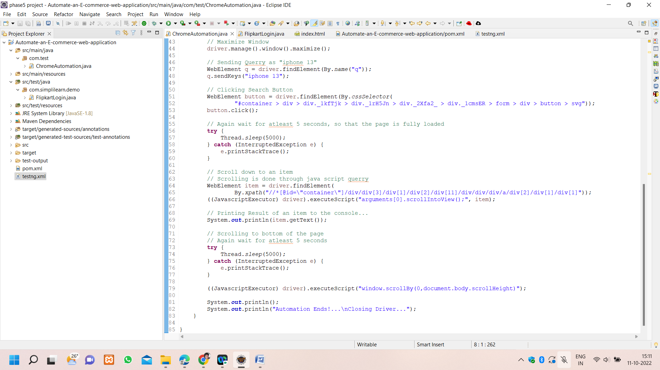

**Output**

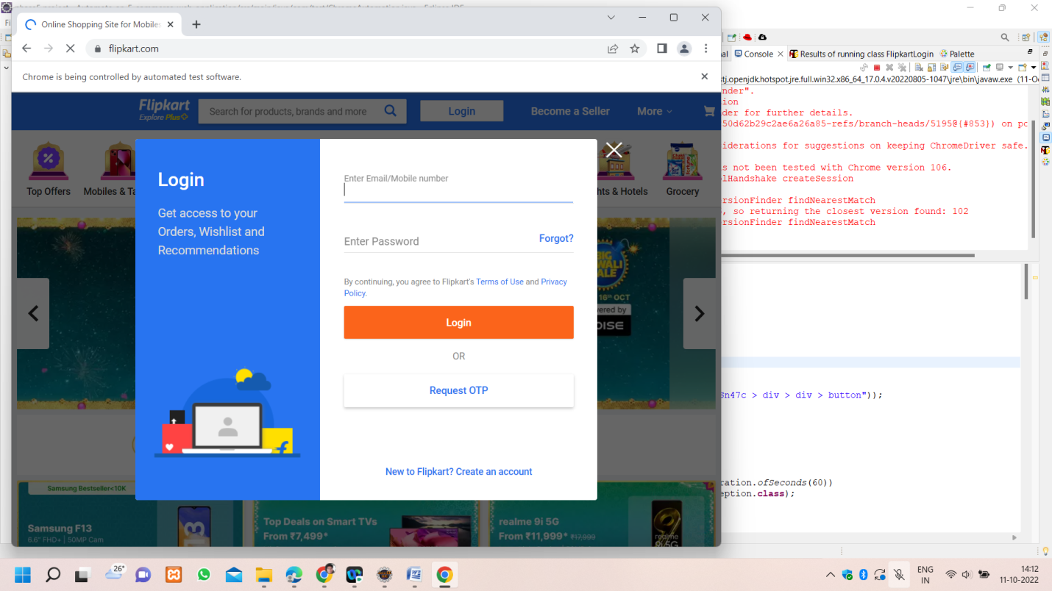

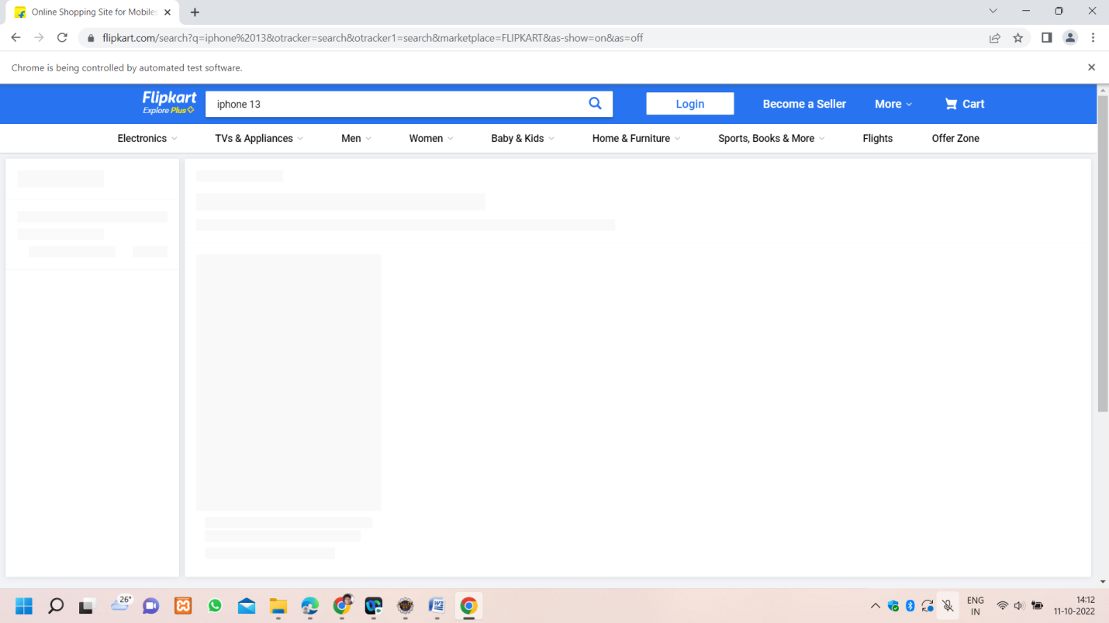

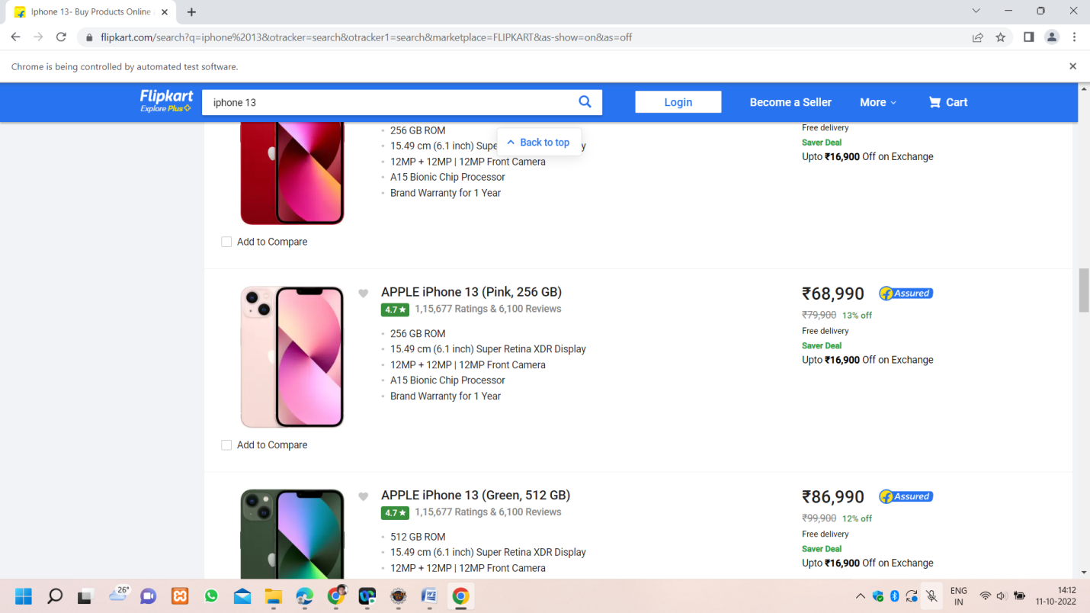

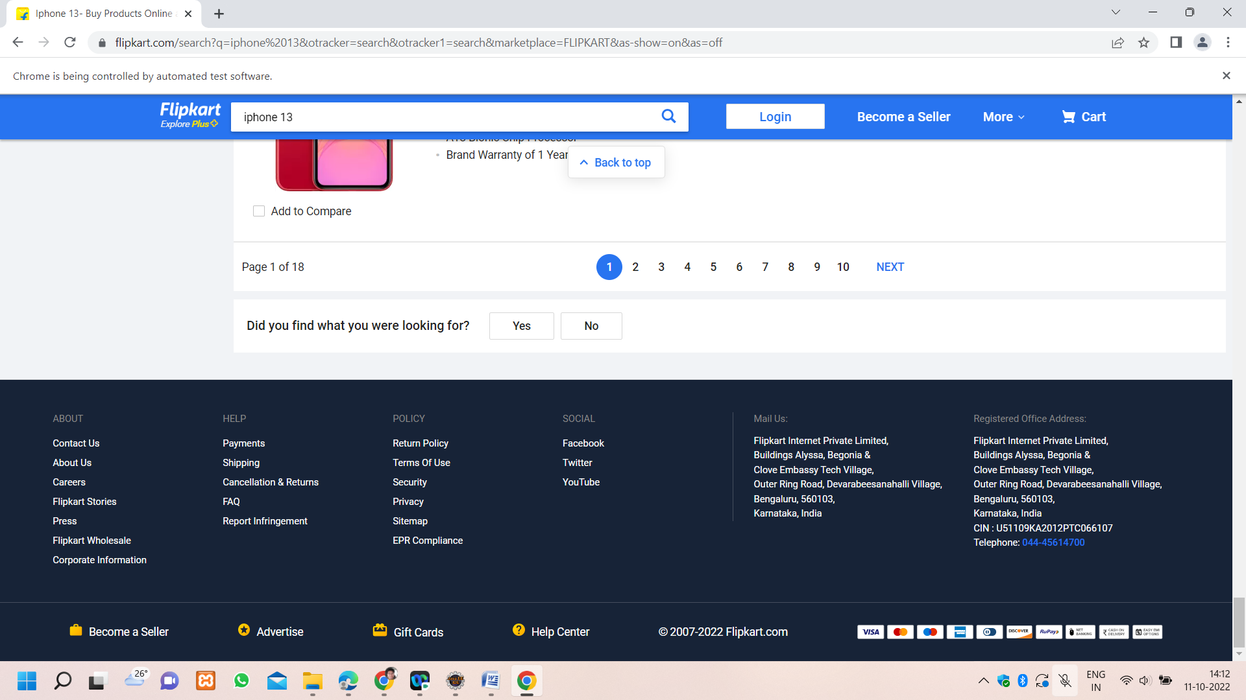

**FlipkartLogin.java**

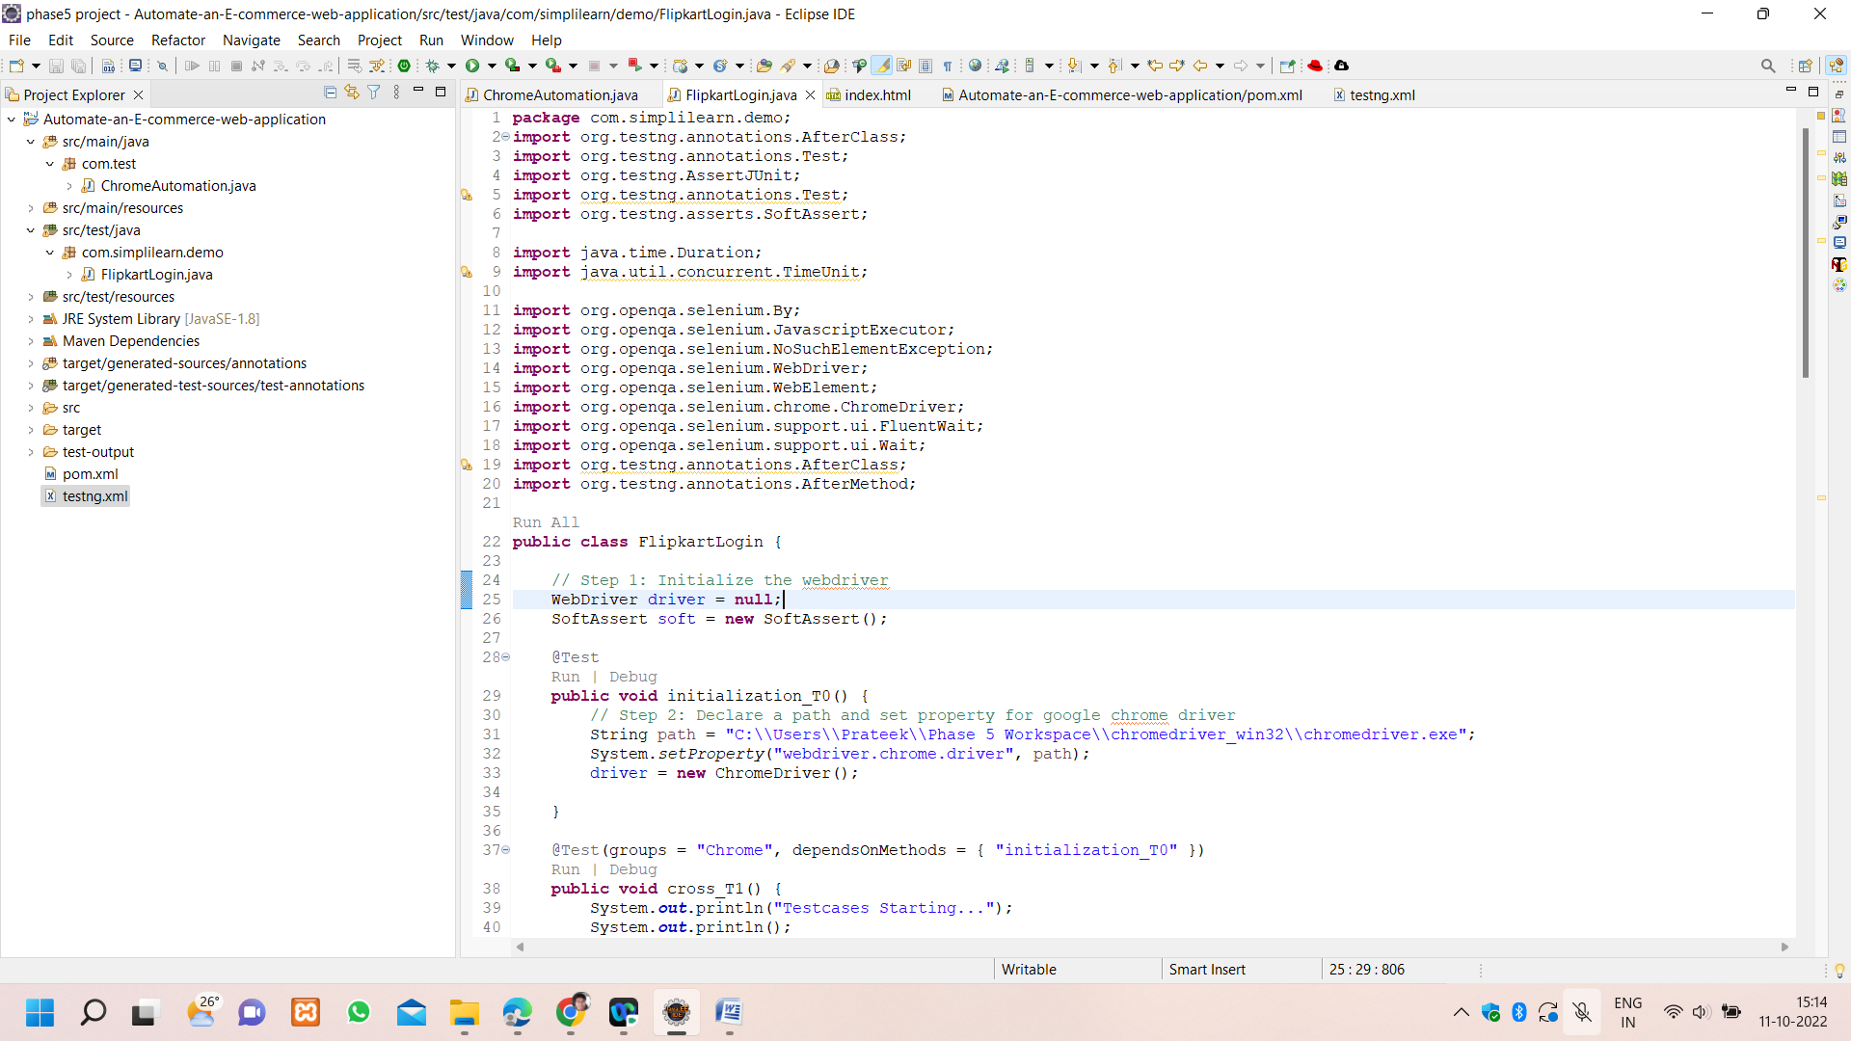

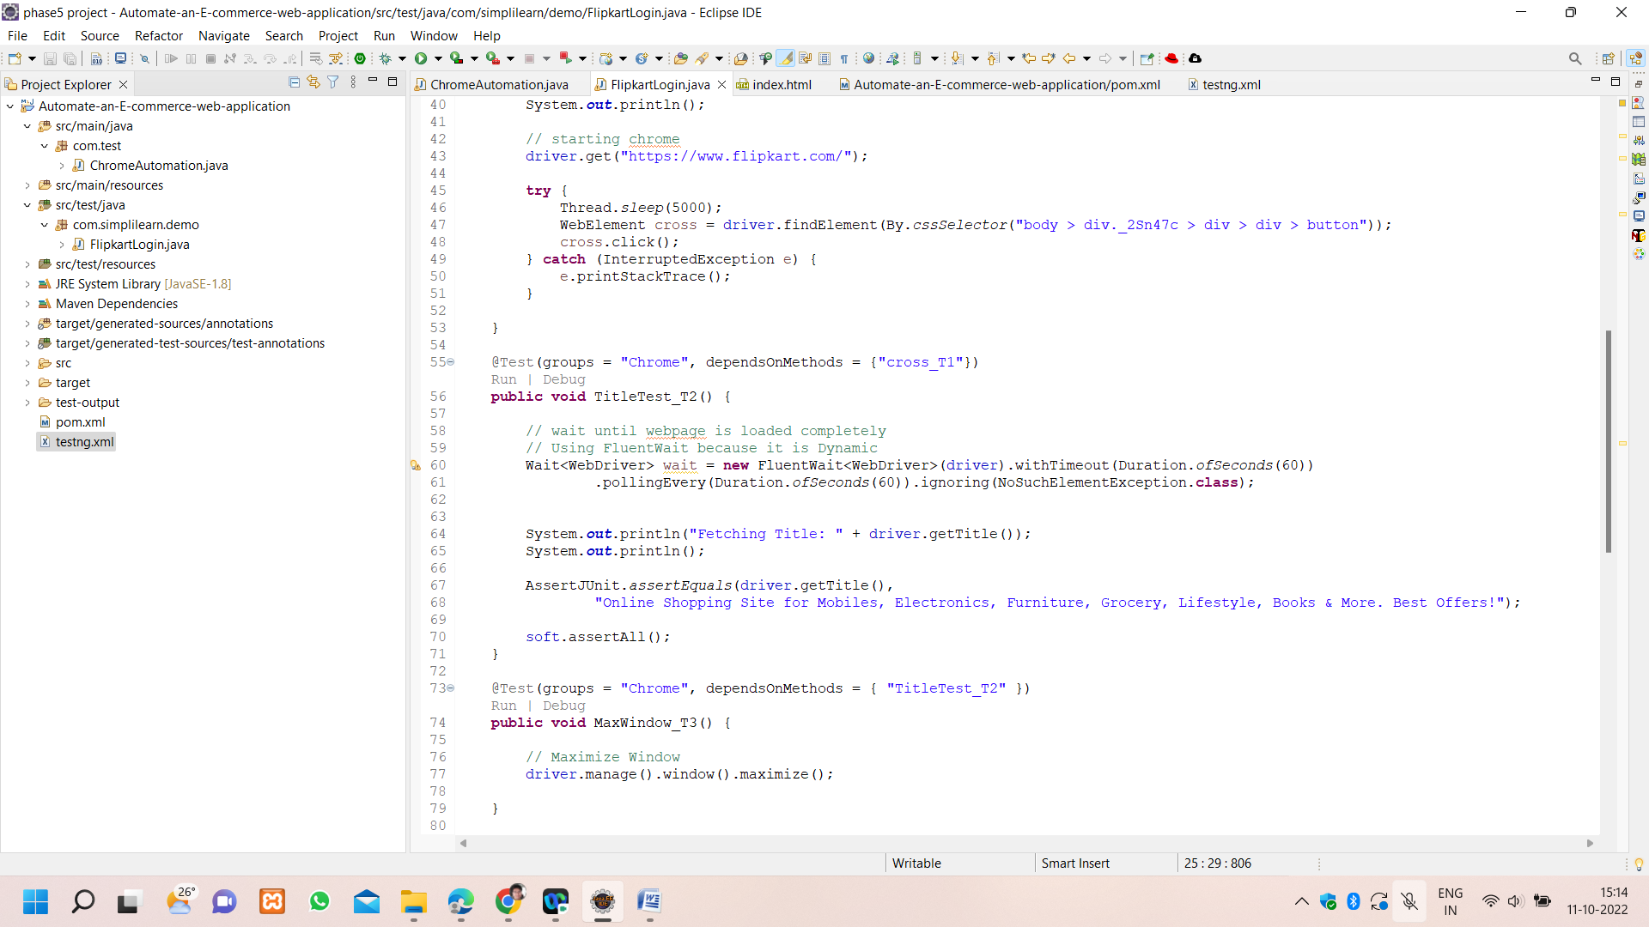

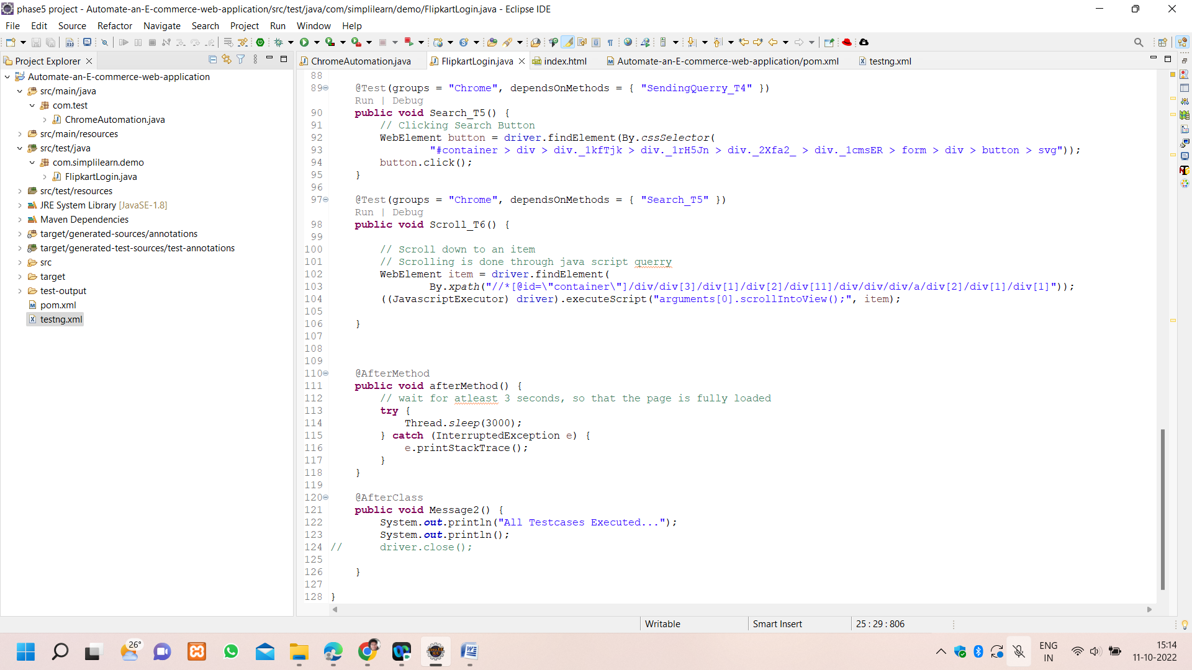

**Output**

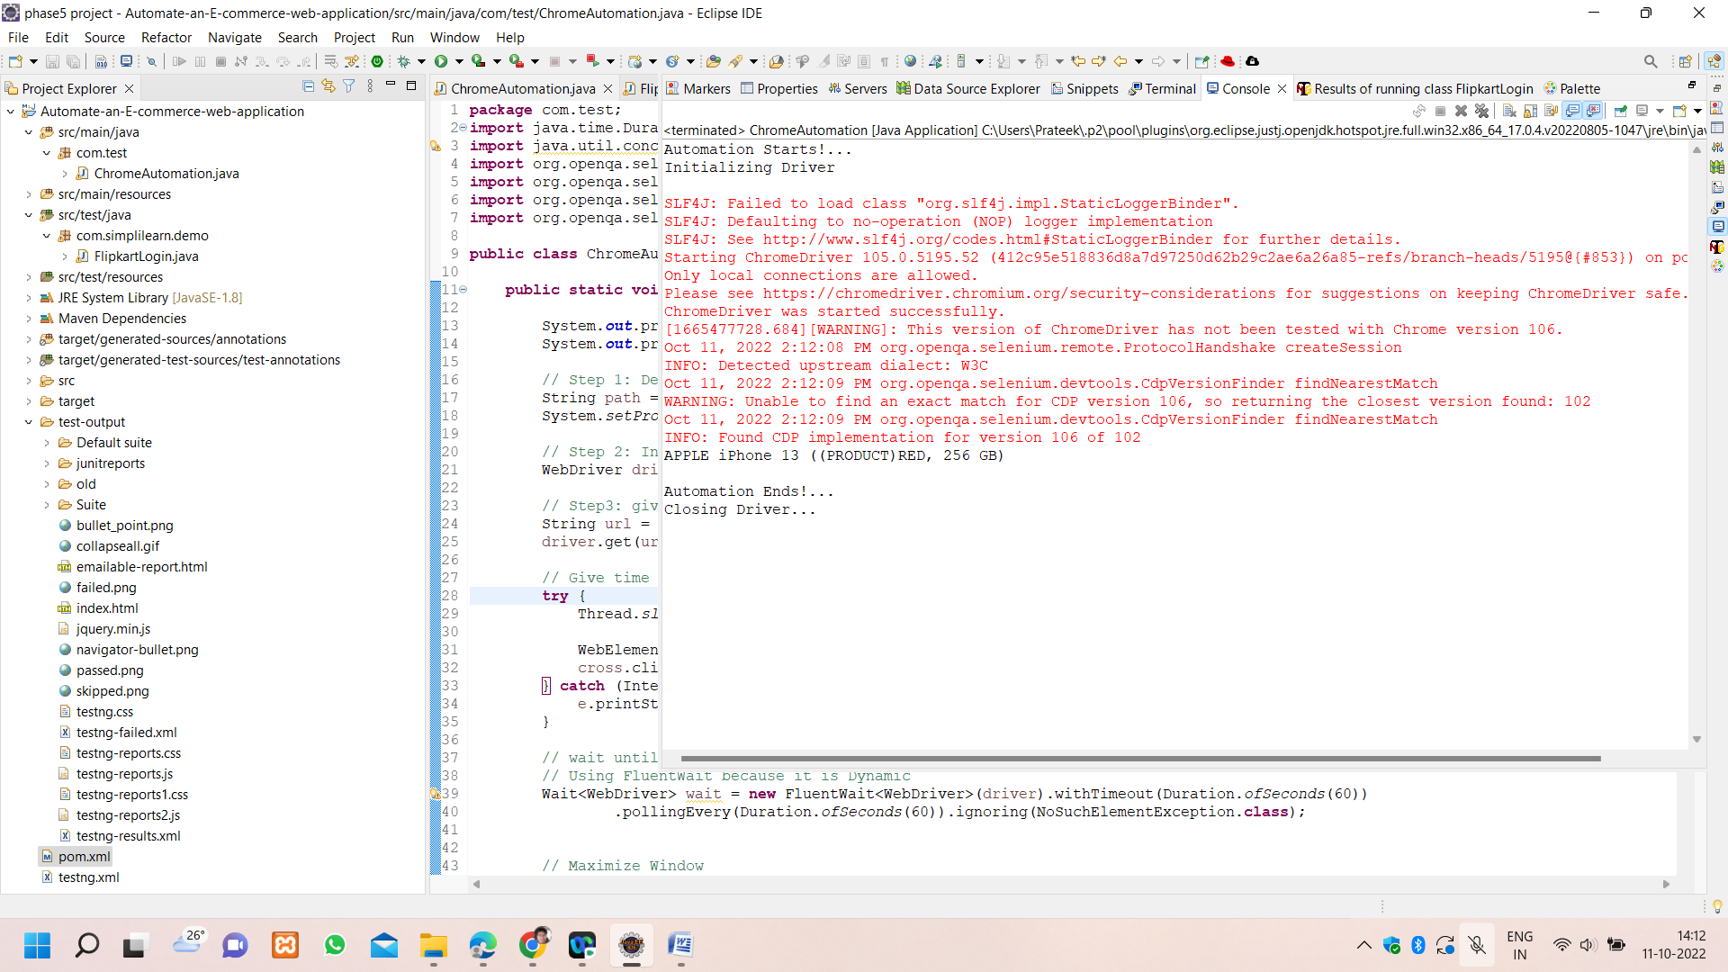

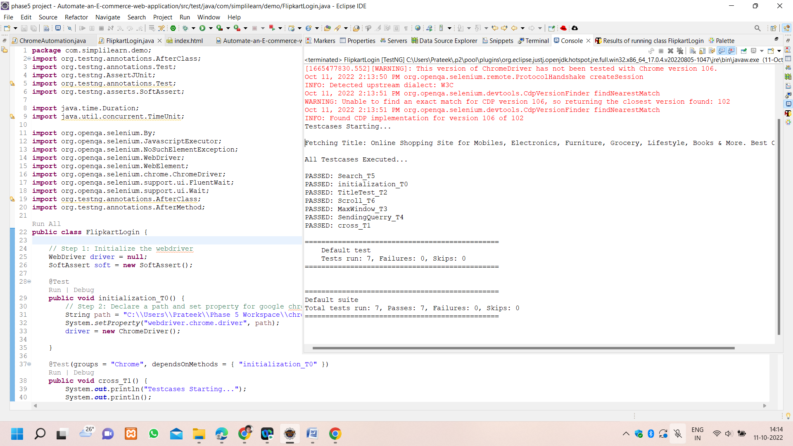

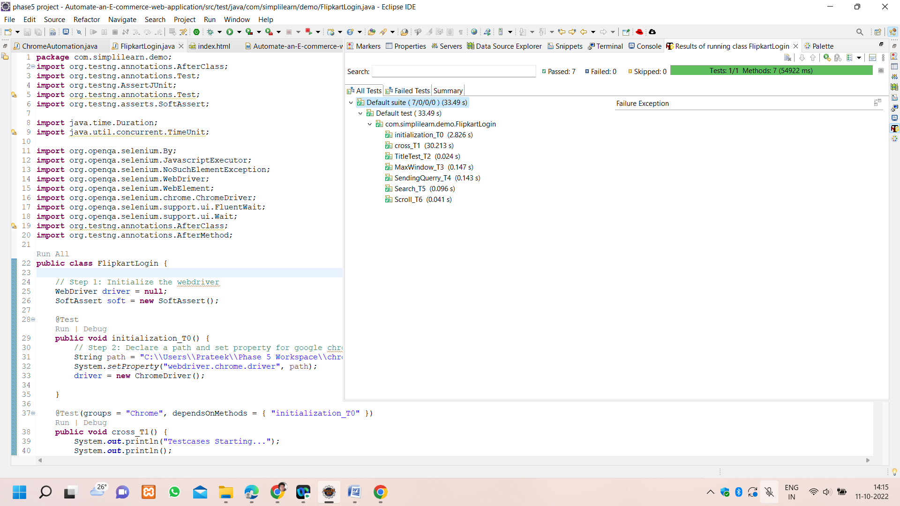

**Index.html 🡪Output**

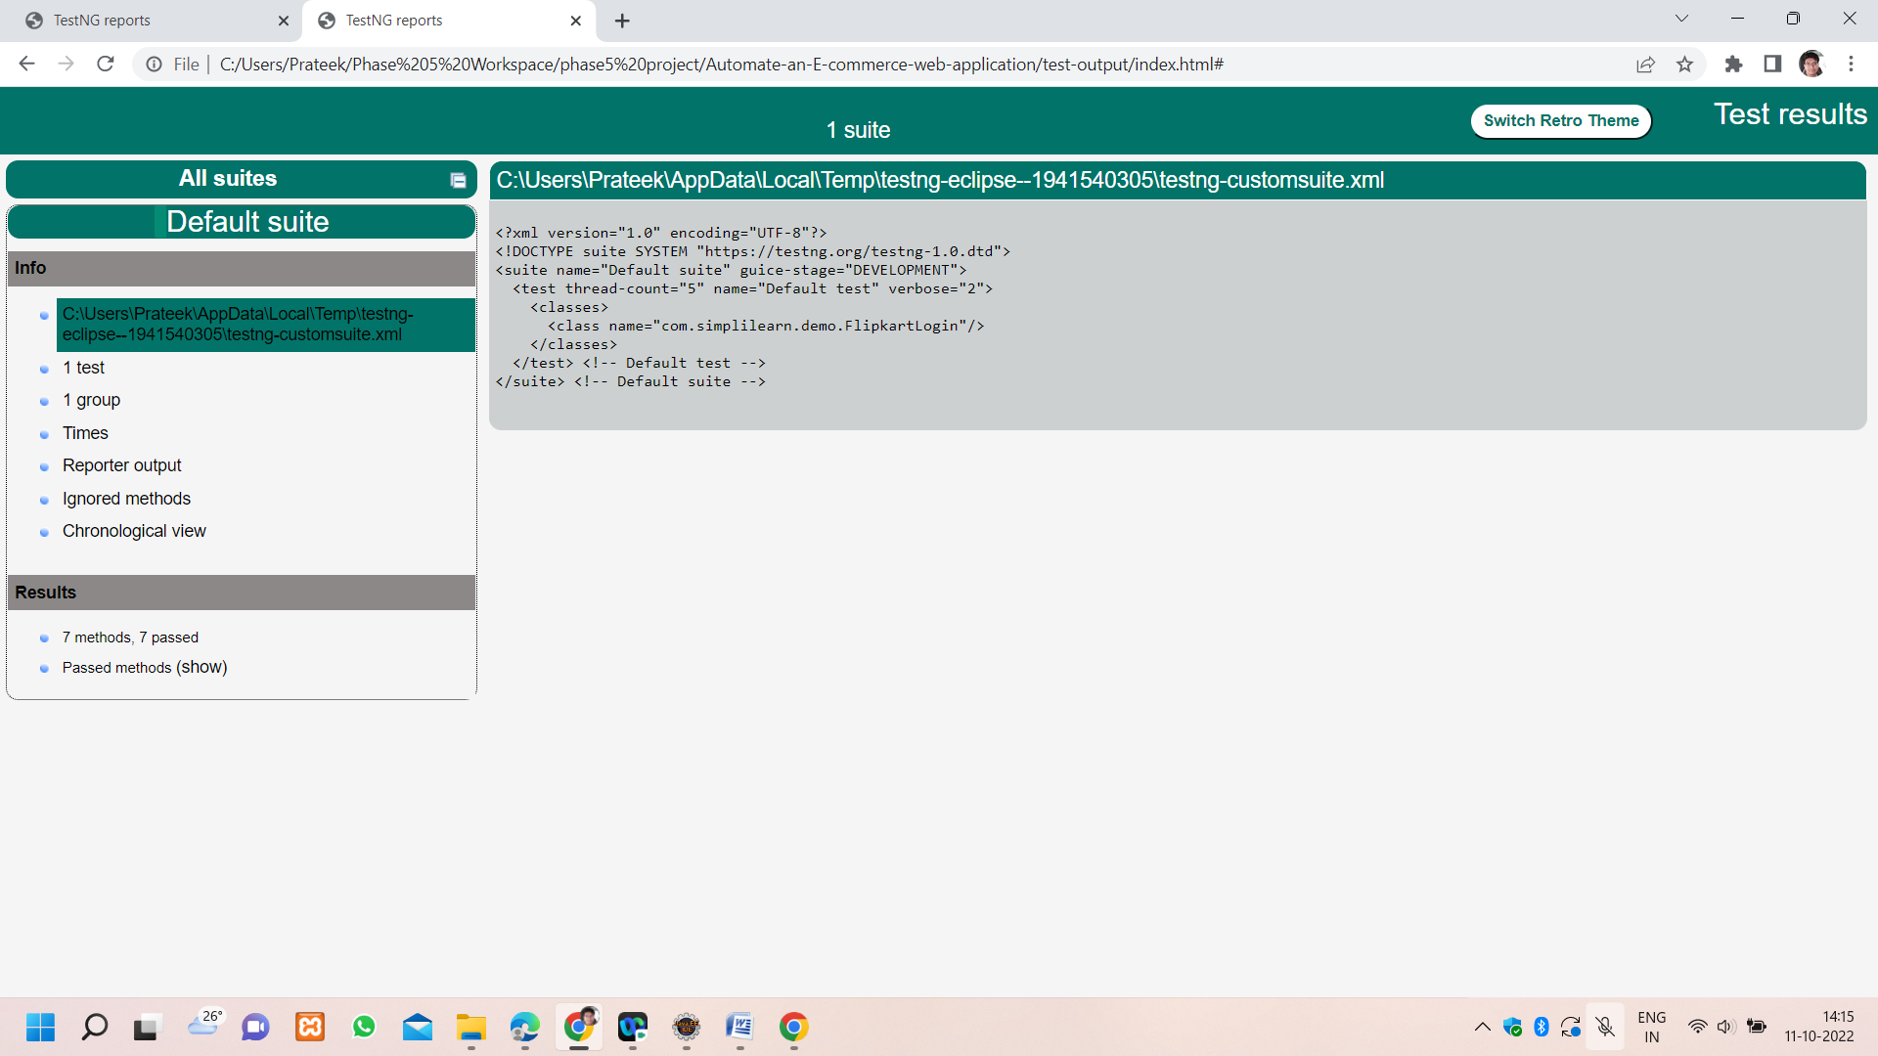

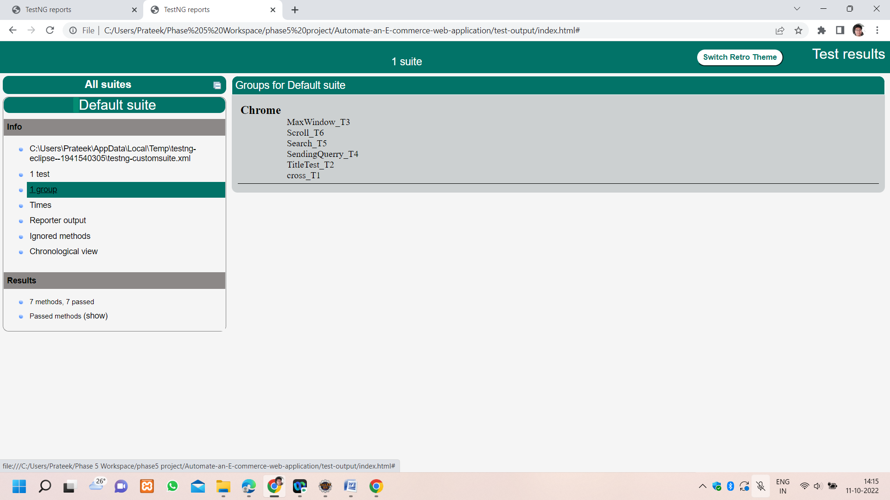

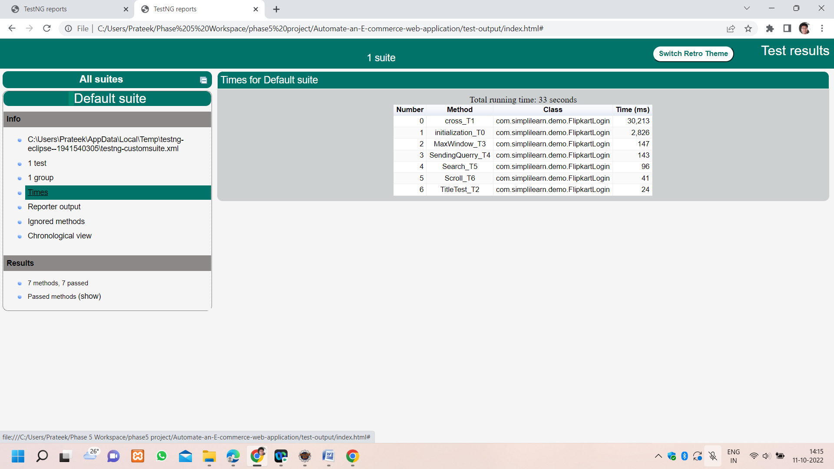

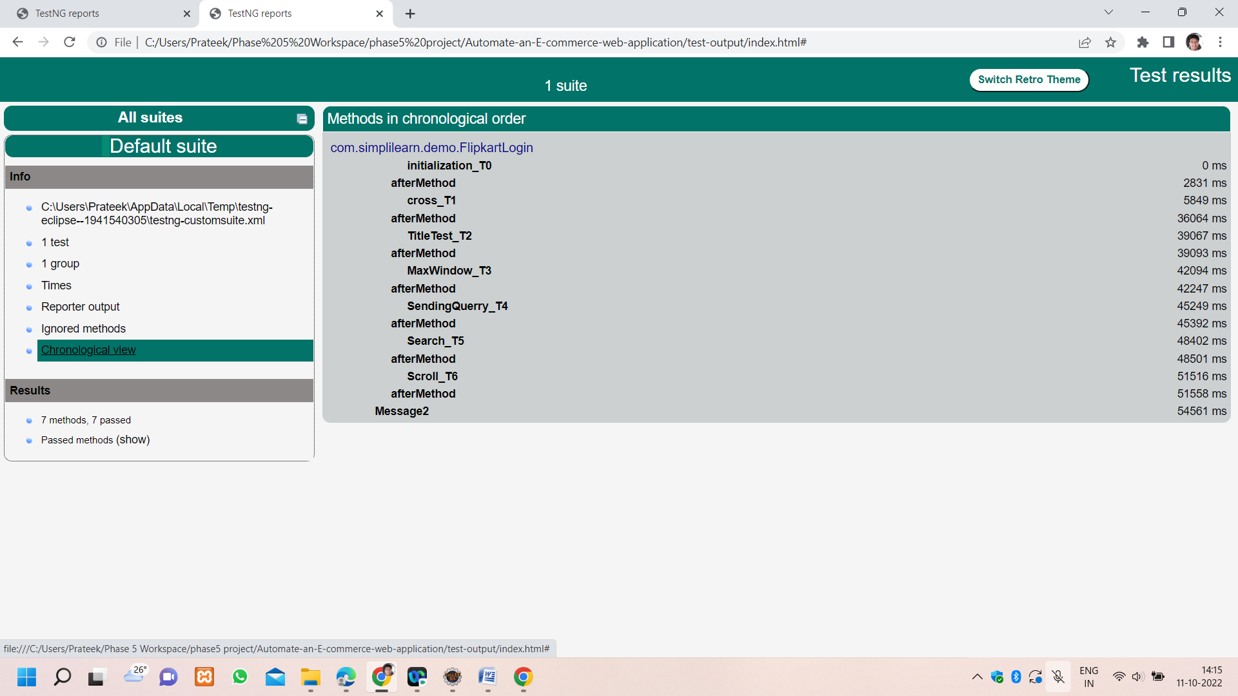

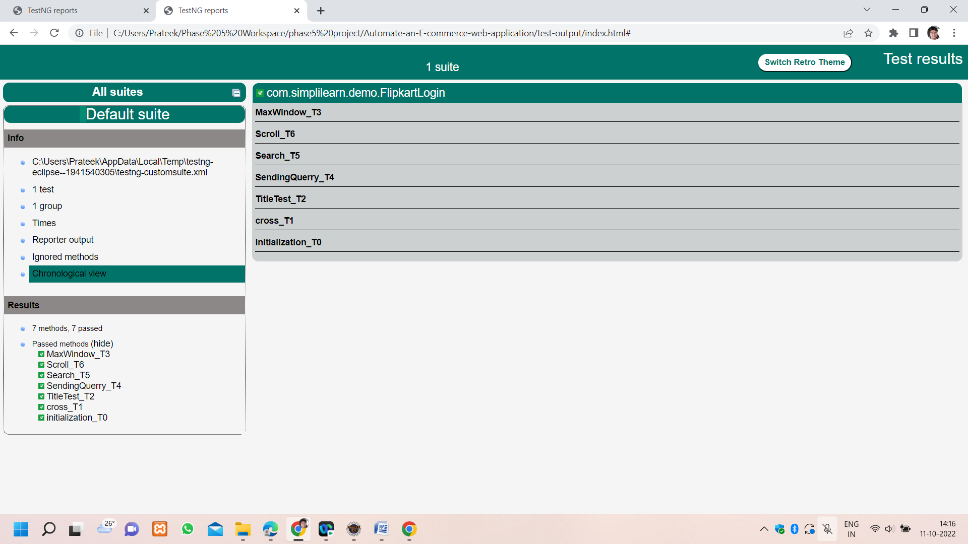

**Step 6:** Pushing the code to GitHub repository

* Open your command prompt and navigate to the folder where you have created your files.

**cd <folder path>**

* Initialize repository using the following command:

**git init**

* Add all the files to your git repository using the following command:

**git add .**

* Commit the changes using the following command:

**git commit . -m <commit message>**

* Push the files to the folder you initially created using the following command:

**git push -u origin master**